**Problem Statement:**

You work for XYZ Corporation. Their application requires a SQL service that can

store data which can be retrieved if required. Implement a suitable RDS engine

for the same.

**While migrating, you are asked to perform the following**

**tasks:**

1. Create a MariaDB Engine based RDS Database.

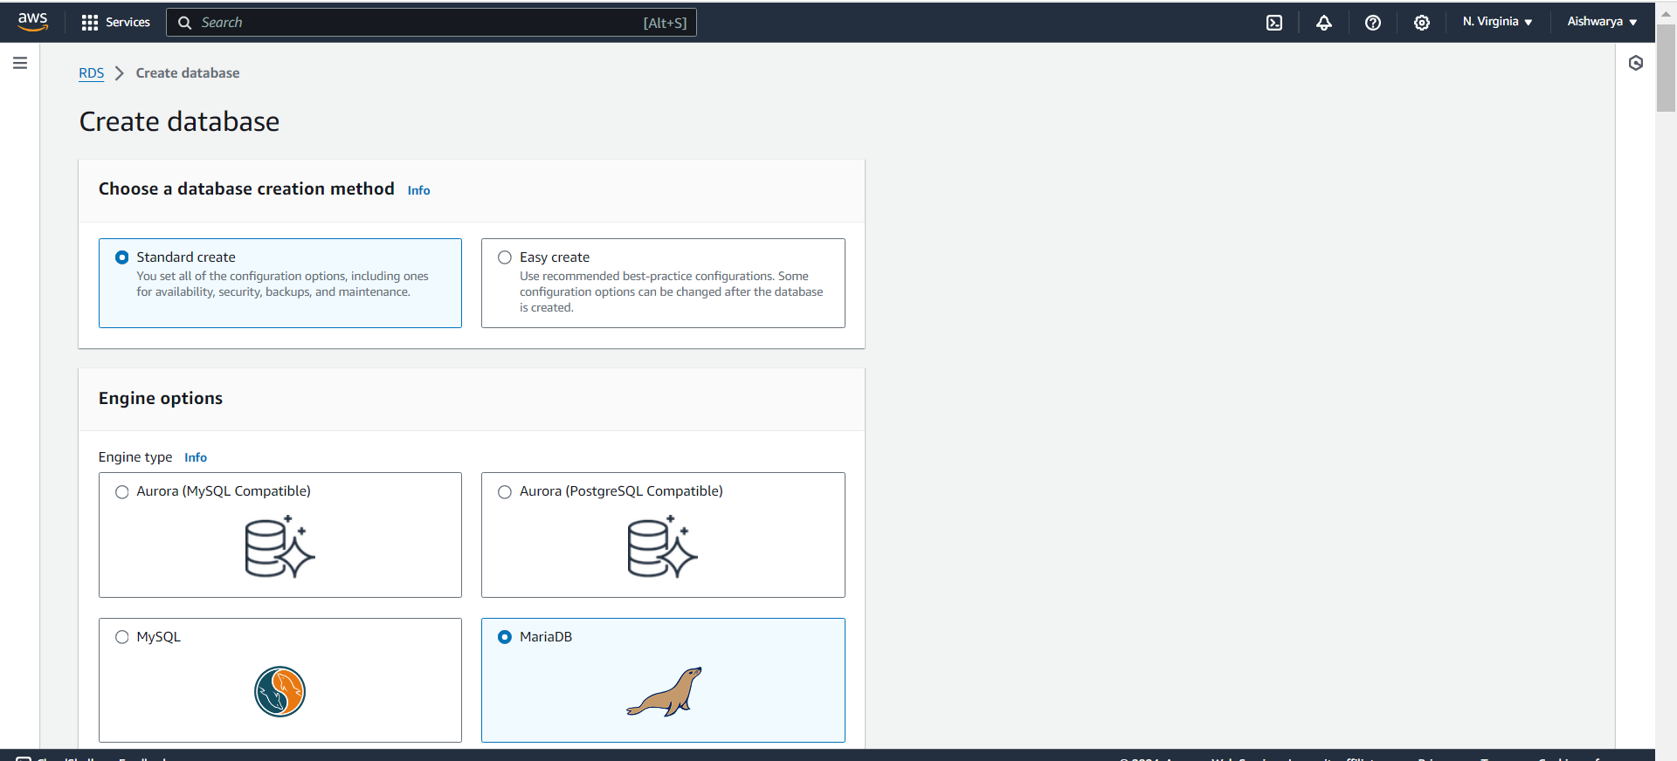

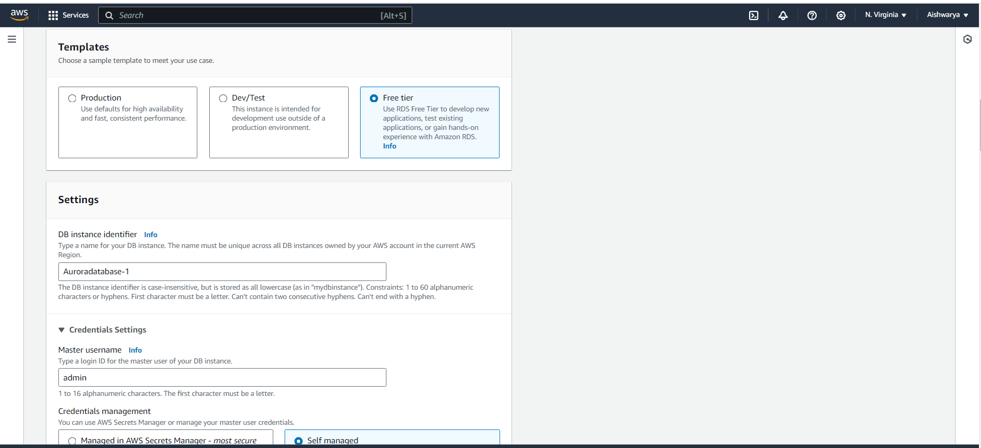

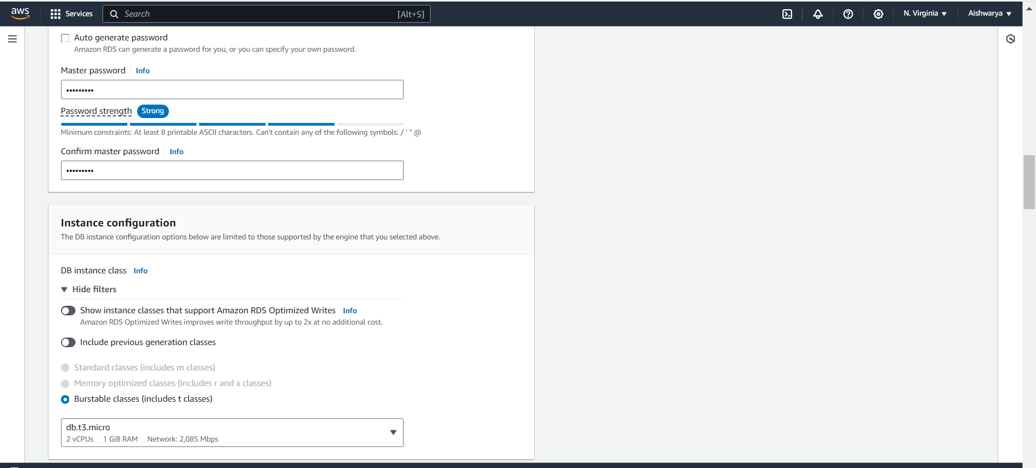

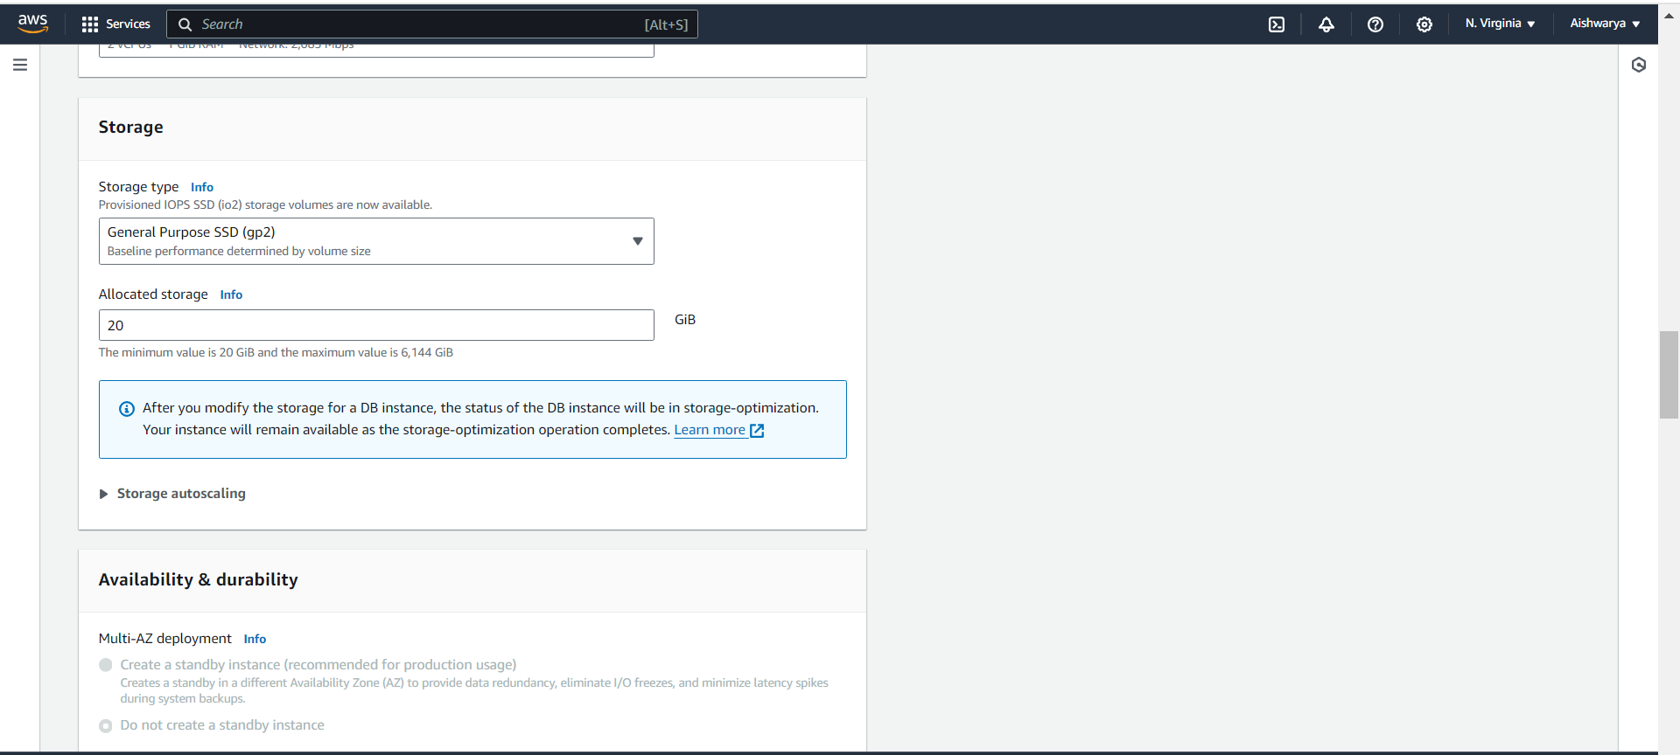

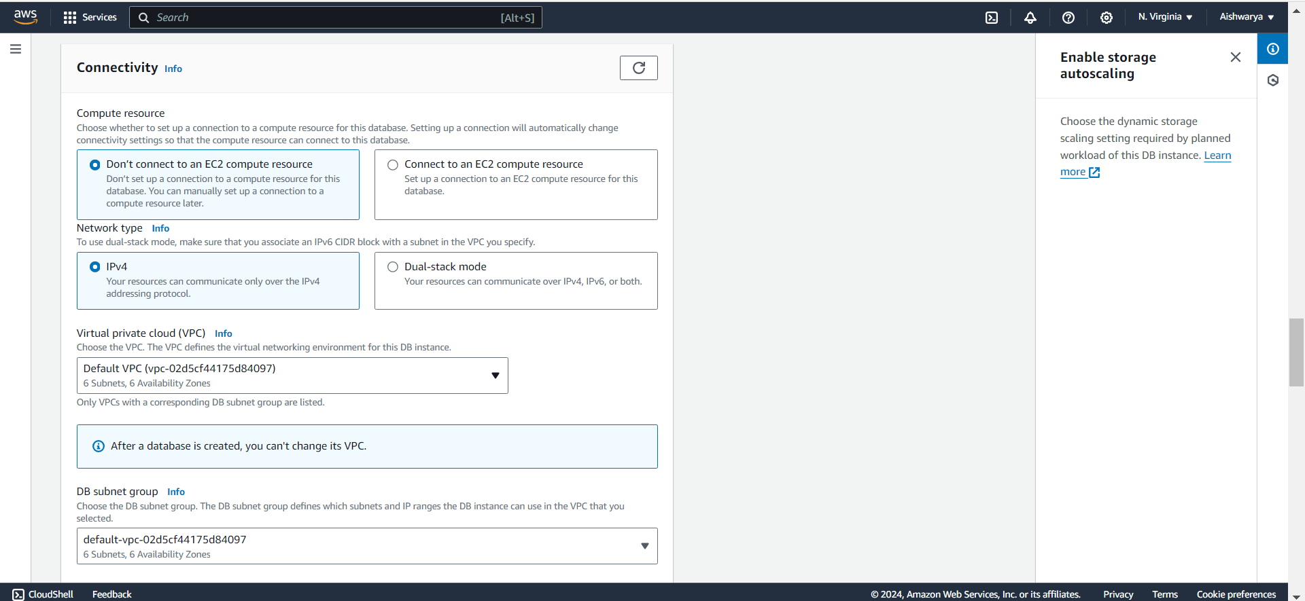

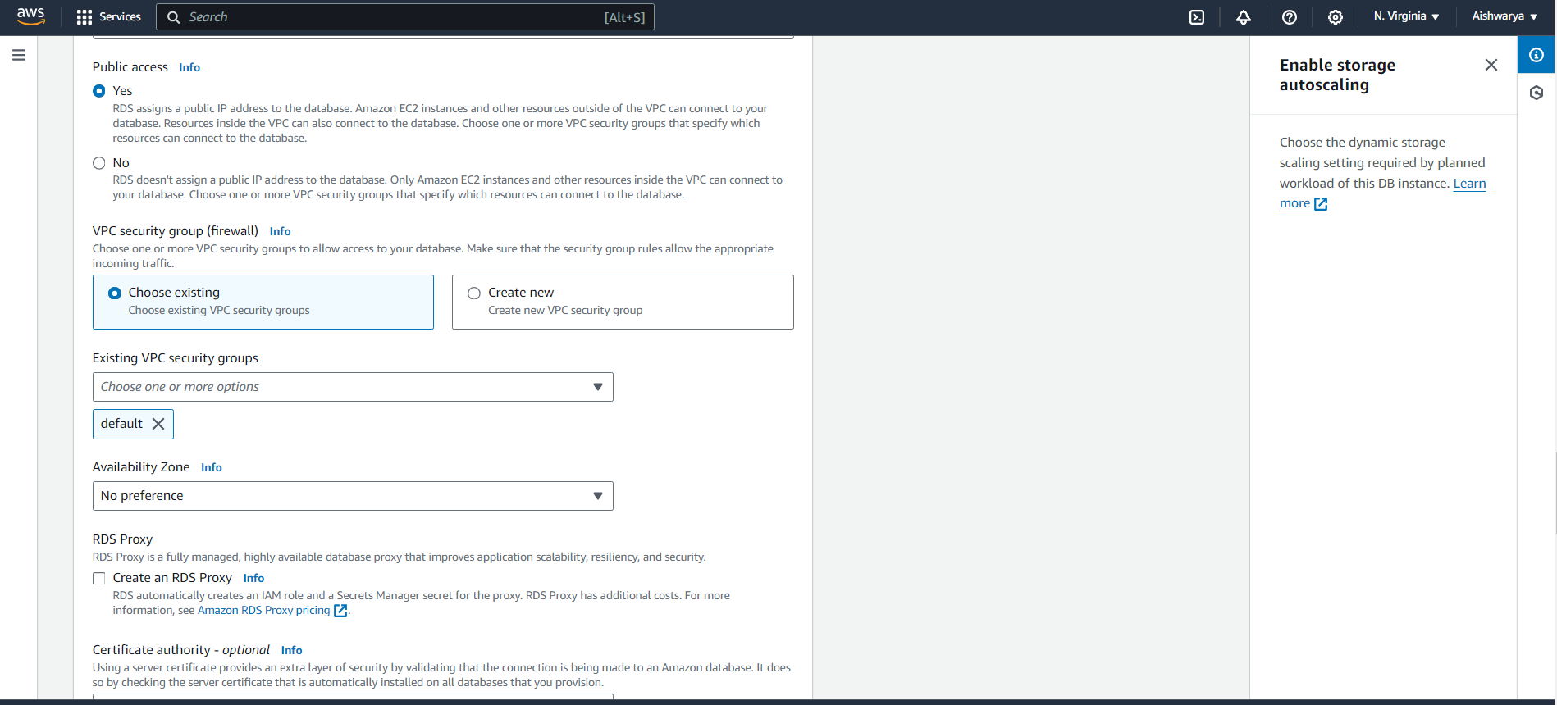

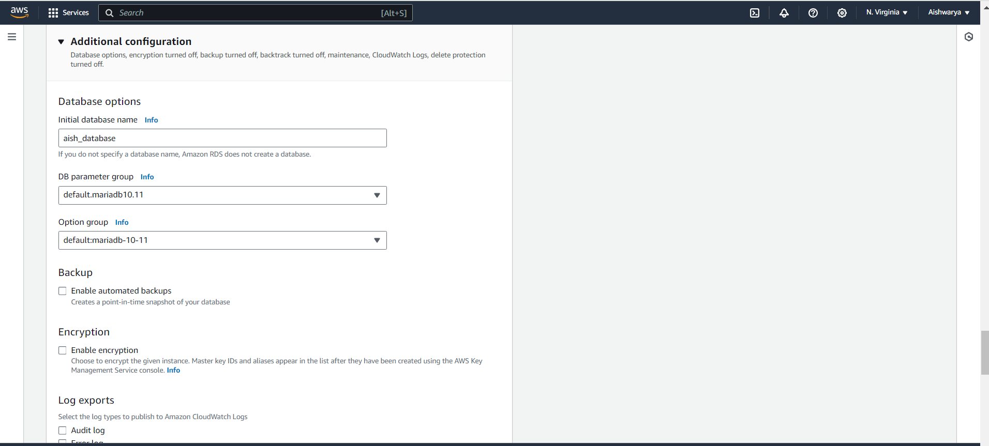

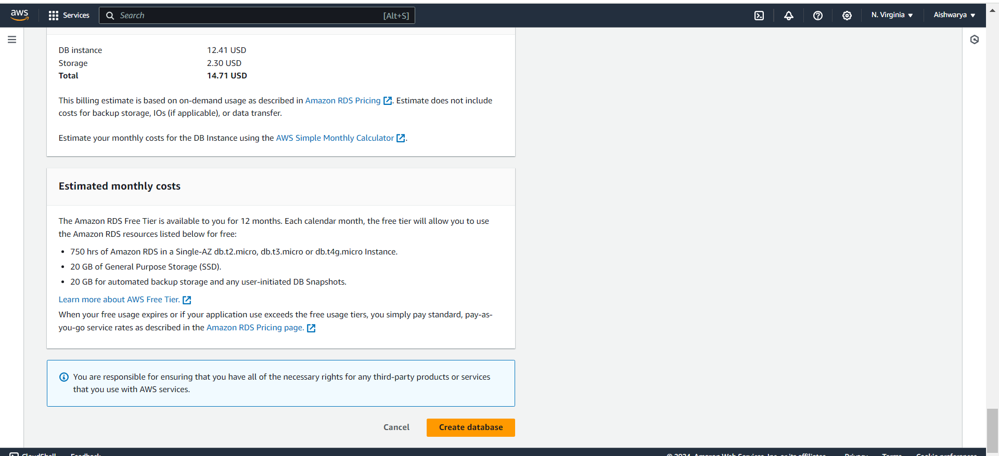

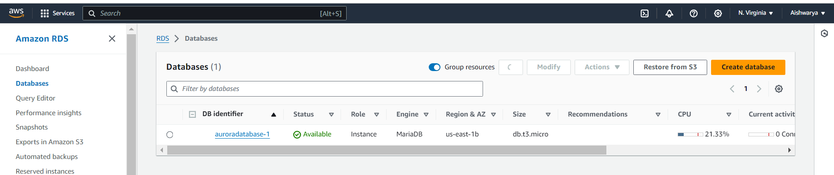

2. Connect to the DB using the following ways:

a. SQL Client for Windows

by using DBeaver we are connecting to DB.

Create new Database connection

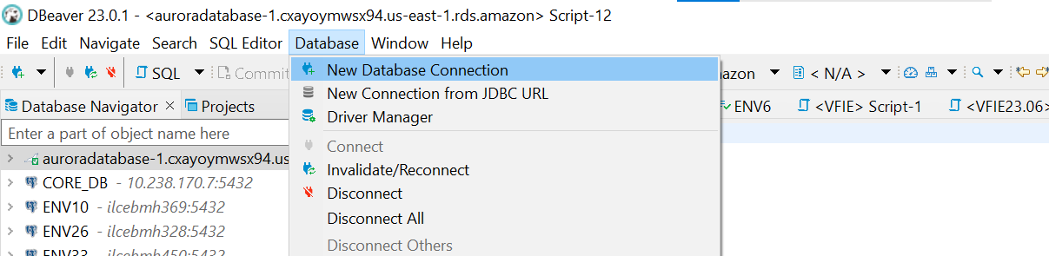

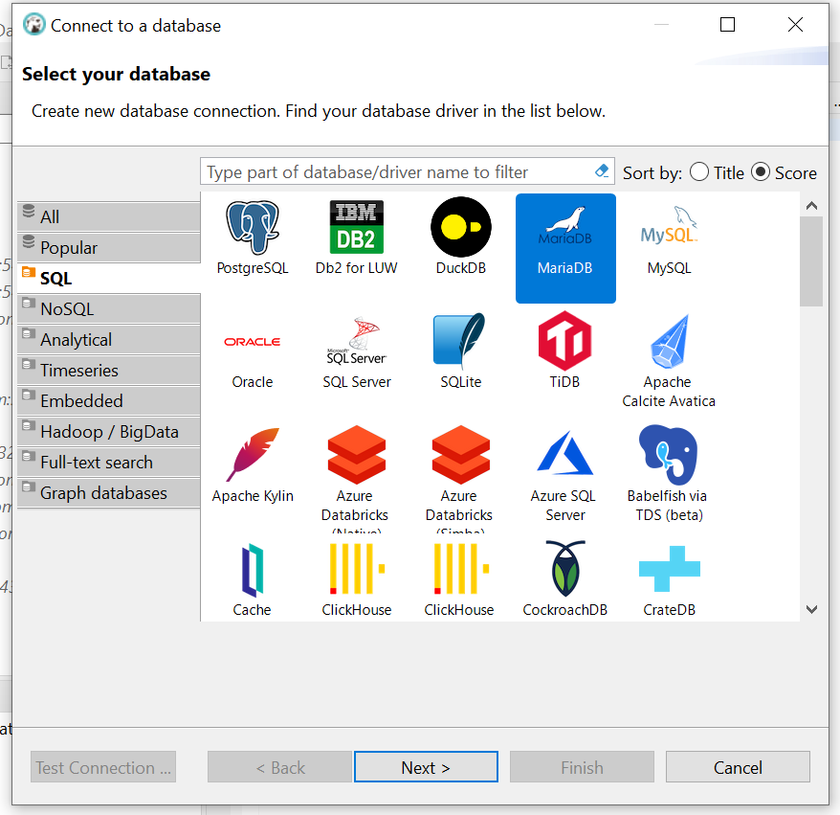

Provide all details like username, password, port and server host name

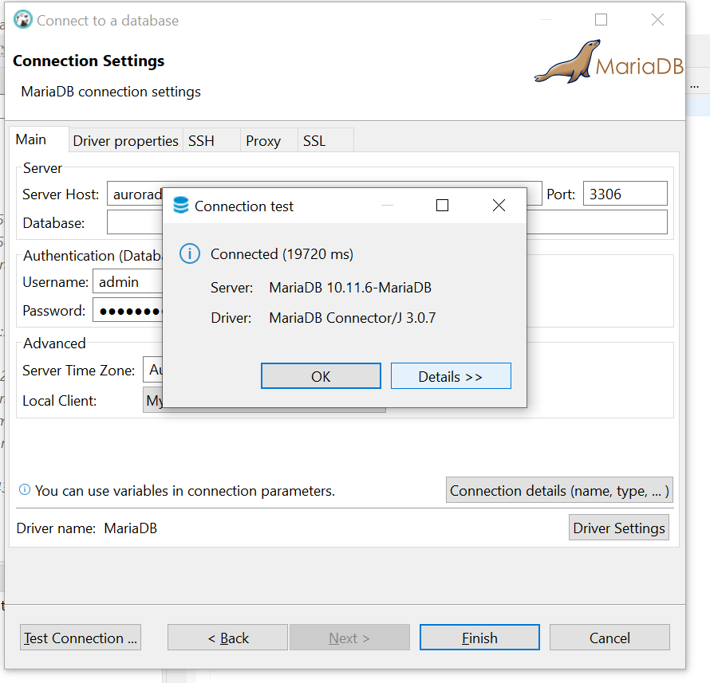

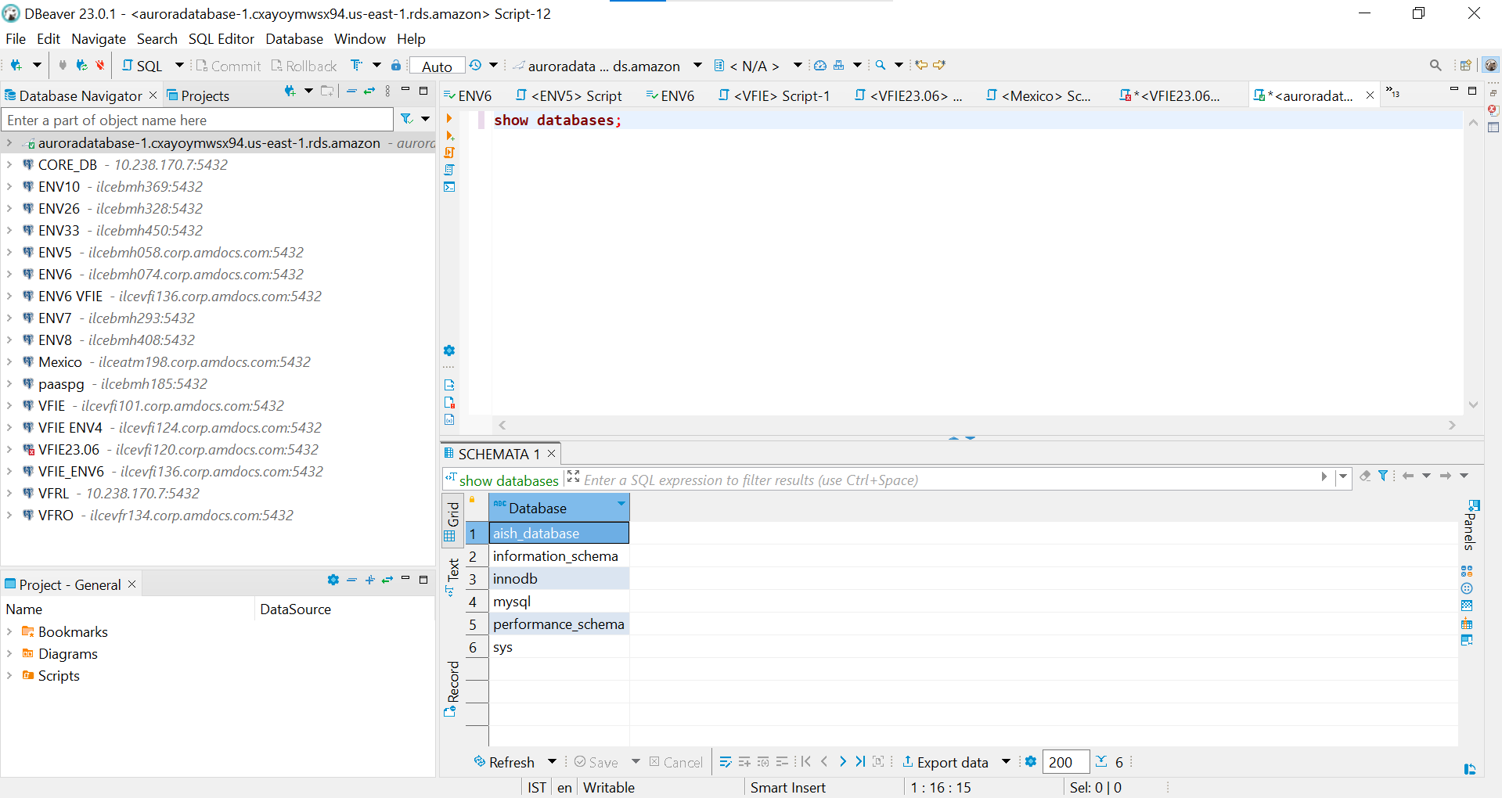

b. Linux based EC2 Instance

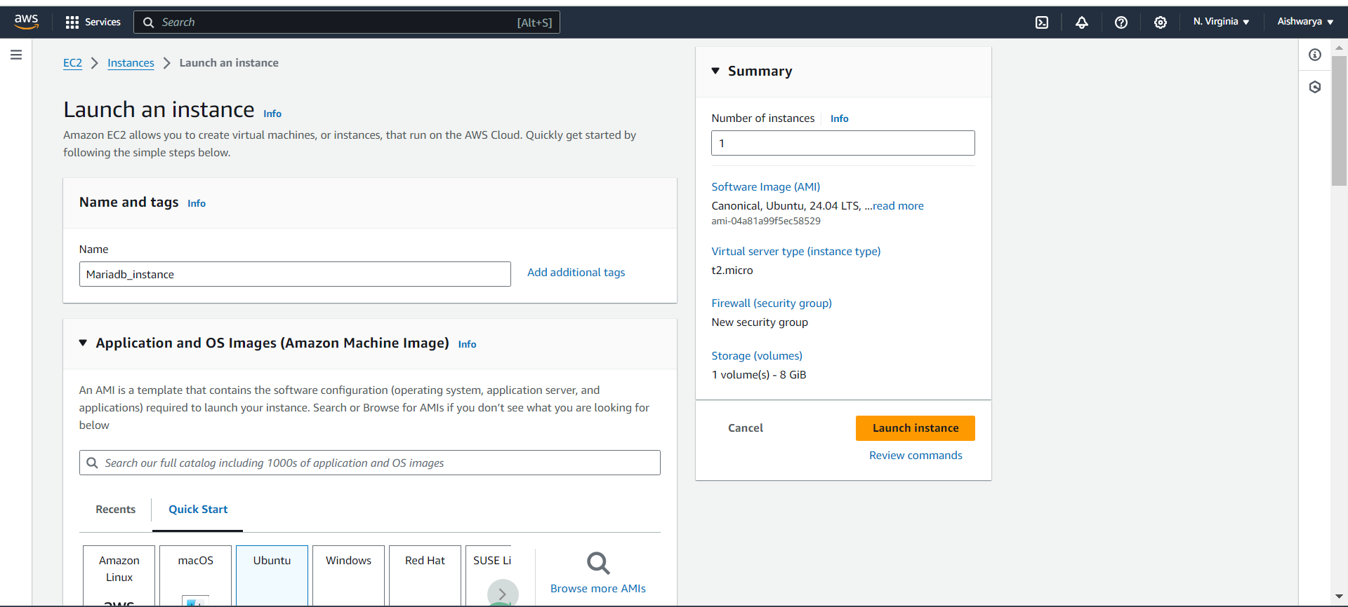

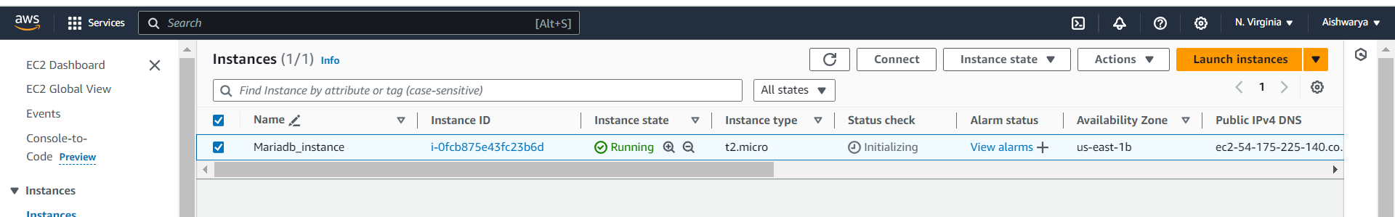

Connect to instance

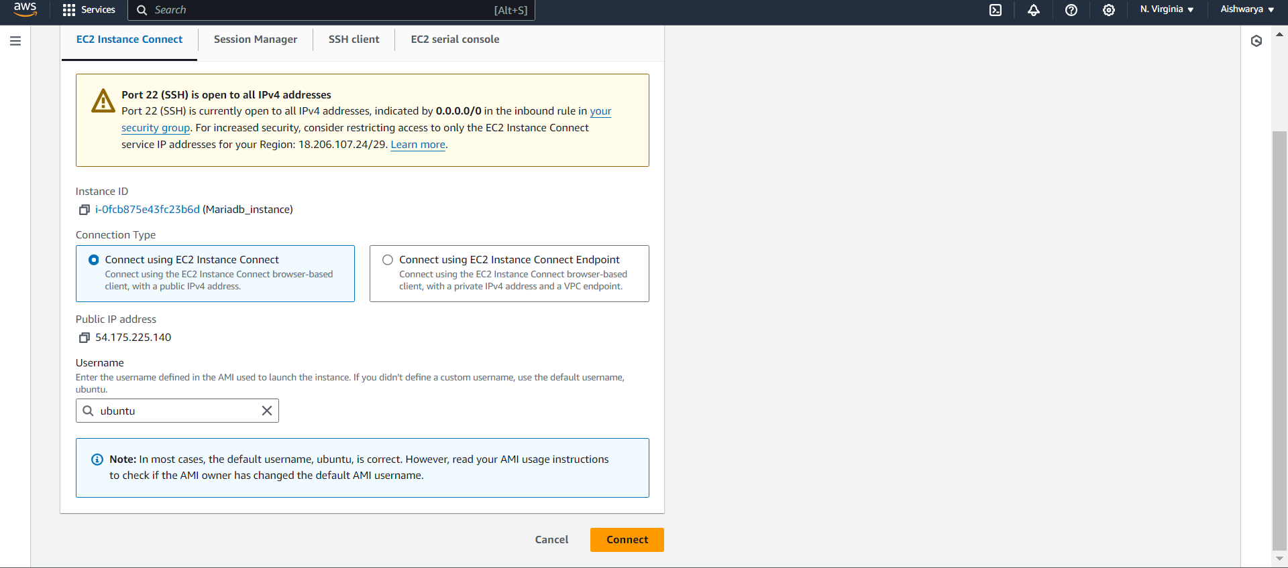

Install my-sql client

sudo apt-get install mysql-client

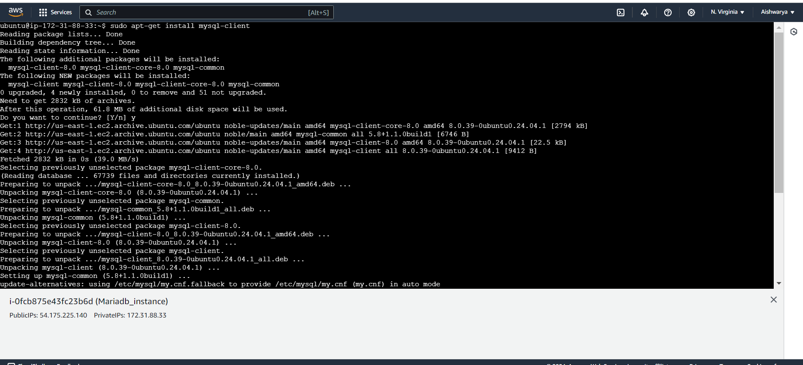

Connect to mariadb database

mysql -h auroradatabase-1.cxayoymwsx94.us-east-1.rds.amazonaws.com -u admin -p

give password!

Connect to database

